# THE SANGANEB MARINE NATIONAL PARK

Sanganeb is an isolated, coral reef structure in the central Red Sea and the only atoll, 25 km off the shoreline of Sudan.

 It includes a highly diverse system of coral reefs, mangroves, seagrass beds, beaches and islets. The site provides a habitat for populations of seabirds, marine mammals, fish, sharks, turtles and manta rays.

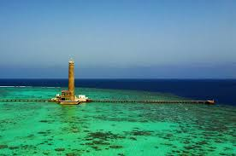

The Sanganeb Marine National Park and the Dungonab Bay – Mukkawar Island Marine National Park are located in the northern part of the Red Sea. The property is a serial site and covers 260,700 ha with a buffer zone of 504,600 ha consisting of both marine and terrestrial areas. The property’s marine systems, fauna and flora are from an Indian Ocean origin, however, due to its semi-enclosed nature, it has developed unique and different ecosystems and species.